**Measuring force at the end effector**

In order to implement an Admittance Control scheme, it is necessary to measure the applied force at the end effector, and further to resolve this force to the global coordinate system. An off the shelf sensor could be utilised, which is the simplest solution. This does not fulfil the aim of the project, which is to produce a low-cost rehabilitation device designed for home installation. Indeed, the optimal off the shelf sensor is equal to the cost of the rest of the device. Realisitcally, it is only necessary to measure 2 DoF normal forces (x and y) for Admittance control.

Standard stuff

A potential solution to this problem is to manufacture a bespoke force sensor, as was done by Richardson (2001), Kim et al (1999), and Chao and Yin (1999). This involves connecting strain gauges to a plate which deforms predictably under load.

Fancy Stuff

In recent years there has been development in low-cost piezoresistive sensors such as Interlink Force Sensing Resistor (FSR), Tekscan Flexiforce, or Peratech QTC. These seem like a cost-effective method, but research shows drift during dynamic loading. This is an issue, since they will likely be subject ONLY to dynamic loading during operation. The paper goes on to suggest that these will be potentially adequate.

Fancy stuff from Leeds

MagTrix as a potential low-cost solution? Tactile sensing like this seems inappropriate, and potentially the sensor footprint may be an issue if is to be integrated into the handle. Further considerations, the magnetic field may be affected by environmental interference according to Dom.

Dom’s work as a potential low-cost solution? Flexible substrate means that the sensor could be wrapped around the handle?

I understand that both of these sensors are sensitive to shear, having been designed as tactile sensors. How do they perform measuring normal force?

Spoke to Pete. MagOne is the way to go.

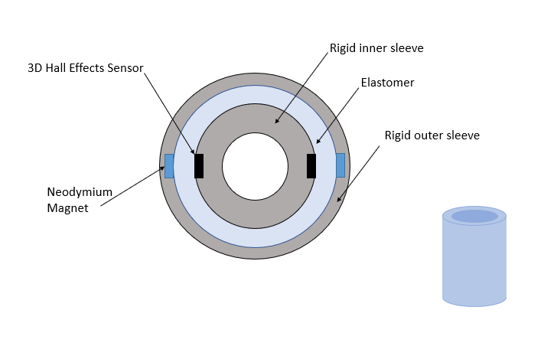

BOM:

* 3D Hall Effect Sensor: TLE493DA2B6HTSA1 <https://www.mouser.co.uk/Sensors/Magnetic-Sensors/Board-Mount-Hall-Effect-Magnetic-Sensors/_/N-6g7qo>

Data Sheet: <https://www.mouser.co.uk/datasheet/2/196/Infineon-TLE493D-A2B6-DS-v01_01-EN-1381645.pdf>

* 6x1mm Aluminium Tubing: <https://www.aluminiumwarehouse.co.uk/6-mm-x-1-mm-aluminium-round-tube>
* 5/8inx10swg Aluminium Tubing: <https://www.aluminiumwarehouse.co.uk/5-8-in-x-10-swg-aluminium-round-tube>
* 3/8x16swg Aluminium Tubing: <https://www.aluminiumwarehouse.co.uk/aluminium/round-tube/outside-diameter/3/8-in->
* Neodymium magnets: <https://uk.rs-online.com/web/p/neodymium-magnets/9093632/>
* Ecoflex 0050: <https://www.benam.co.uk/products/silicone/addition/ecoflex/>

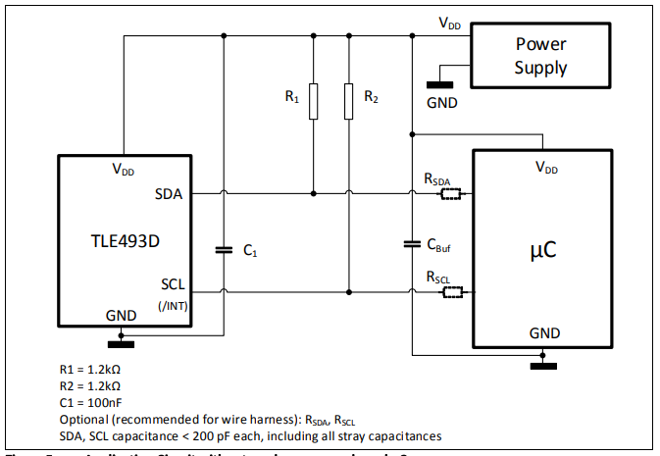

uC is microcontroller

